**Specific Heat**

[Modified from PASCO lab manual #52]

**Pre-lab questions**

1. What is the goal of this experiment? What physics and general science concepts does this activity demonstrate?
2. What is the definition of specific heat?
3. In what applications is a high specific heat of a material desirable? For what applications would you want a material with a low specific heat? Why?
4. Water has a specific heat of 4.186 J/g°C, whereas the metals in this lab have specific heats less than 1 J/g°C. Why is it so important to the Earth that the specific heat of water is so high [Hint: Earth’s surface is mostly composed of water]?

The goal of the experiment is to determine the specific heat of a metal sample. In this activity you will use a temperature sensor to measure the temperature change of a volume of warm water when a cold piece of metal is placed in it. Your data will be used to determine the total amount of heat transferred from the warmer water to the cold metal, which will in turn be used to determine the specific heat of the metal sample.

**Equipment:**

* Wireless temperature sensor
* Density set
* Energy transfer calorimeter
* Centigram balance
* Hot plate
* 600-ml beaker
* 100-ml graduated cylinder
* Scissors
* Thread (1-m)
* Paper clip
* Ice
* Water
* Paper towels
* Coffee stirrers

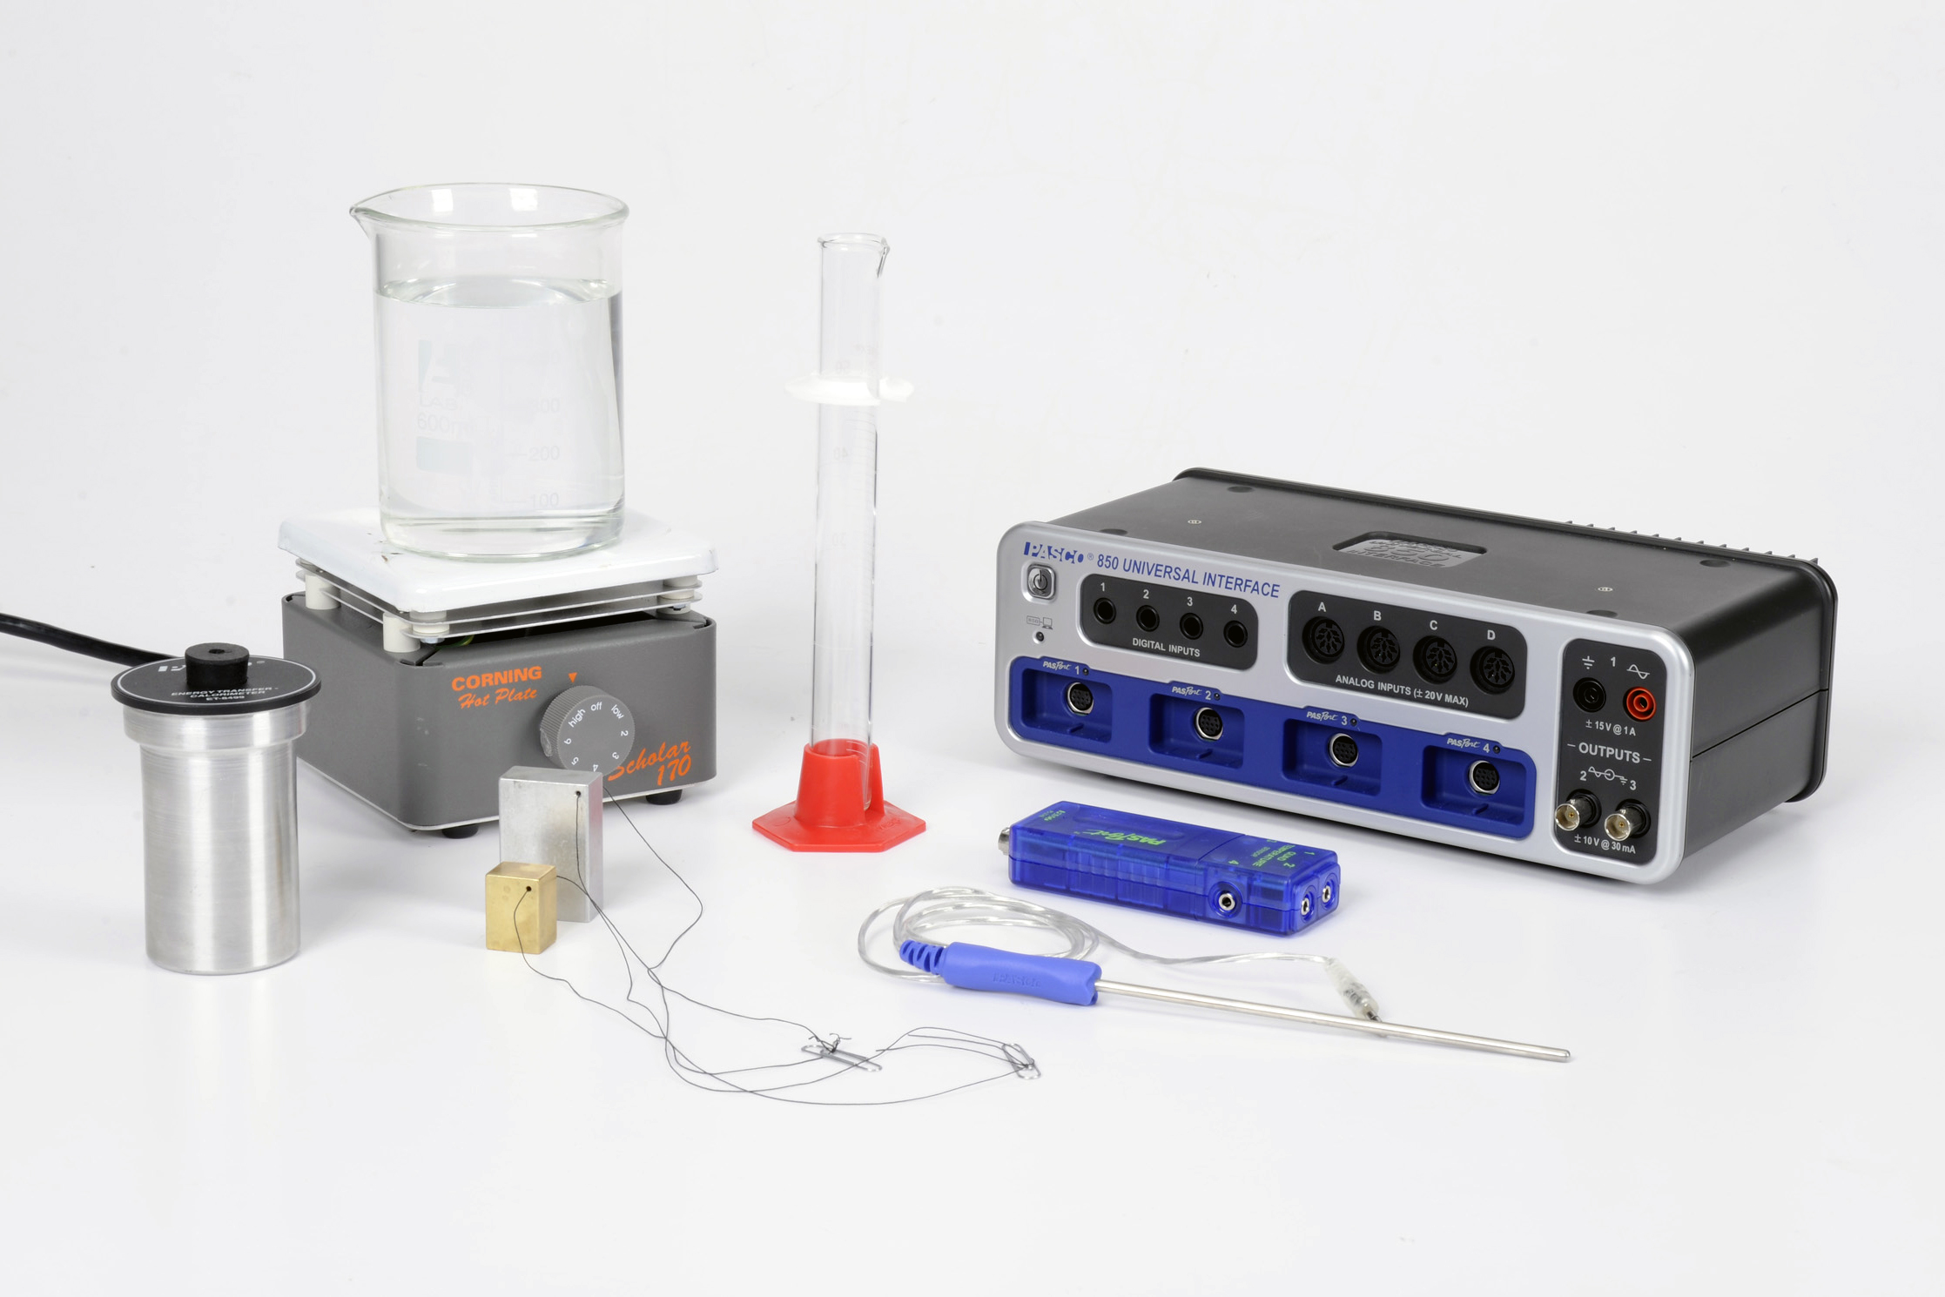

Figure 1: Specific Heat Experiment Equipment

**Introduction:**

The specific heat, c, of a substance describes the amount of thermal energy (heat) that a single gram of the substance must absorb in order to change its temperature by one degree Celsius (or Kelvin).

The specific heat of water, for example, is cW = 4.186 J/g°C. That is: 4.186 J of heat are needed to raise the temperature of 1g of water by 1°C. In general, we have:

Q = mcΔT(1)

where *Q* is the thermal energy (heat) required to produce a temperature change *ΔT* in a material with a specific heat *c* and a mass *m*.

If there is no loss into the environment, when a cold metal is added to warm water, the heat gained by the metal (*QM*) must equal the heat lost by the water (*-QW*) and the aluminum can (*-Q*c) and we have:

QM = -QW - QC (2)

$m_{M}c_{M}∆T_{M}=-m_{W}c_{w}∆T_{w}-m_{c}c_{c}∆T_{c}$

Note that the change in temperature for the can is the same as it is for water. Solving for the specific heat of the metal gives:

$c_{M}=\frac{-\left(m_{w}c_{w}+m_{c}c_{c}\right)∆T_{w}}{m_{M}∆T_{M}}$ (3)

**Experiment**

***Set up***

* Connect the stainless steel temperature probe to port # 1 on the Wireless Temperature sensor and then connect the sensor to any of the PASPORT channels on the 850 interface.
* For this activity you will be using only the gold and silver-colored rectangular metal samples from the ME-8569 Density Set. Each of the two samples has a small hole drilled through it that will be used to attach a piece of thread to help lift the samples during data collection without touching them with your hands.
* Run a small piece of thread (~50 cm) though the hole in each metal sample and tie the ends of the string to create a loop similar to Figure 2. Attaching a paper clip to the loop will create a small handle to help when lifting the samples.

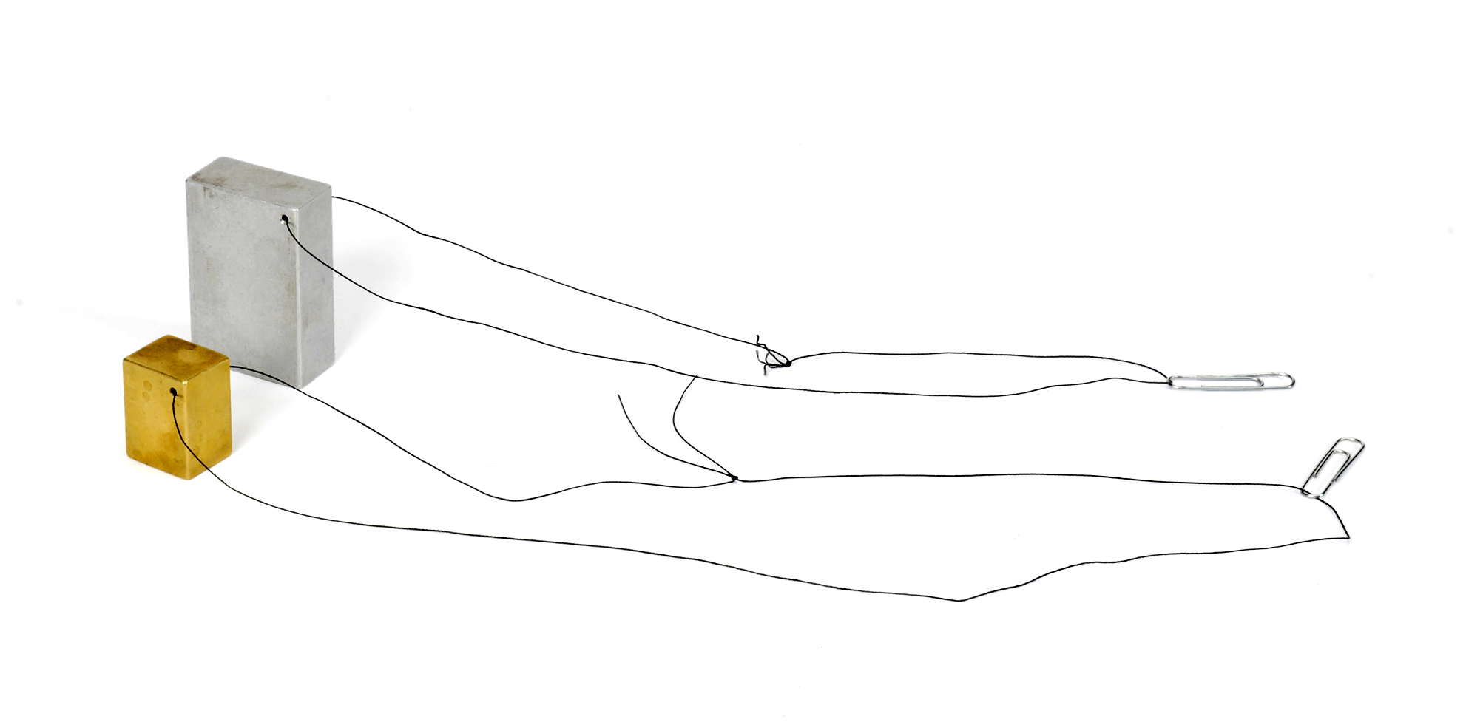

Figure 2: Metal samples with string attached.

* Fill one 600 ml beaker with ice, and then add enough water to the ice to just cover it. Place both metal samples into the ice bath and hang the string and paper clips over the side of the beaker. Leaving the metal samples in the ice bath will eventually cool them to about 0 °C.
* Fill the other 600 ml beaker with approximately 300 ml of water and place the beaker onto the hot plate. Turn on the hot plate and set it to a medium-high heat setting.

* In PASCO Capstone, create a Digital display and select the Temperature. Set the sample rate to 1 Hz. Change the Sampling Mode to Fast Monitor.
* The goal is to heat the water in the beaker to approximately 60 °C, but no hotter. Monitor the temperature of the warm water by placing the temperature probe into the water and clicking the Monitor button.
* While the water is warming, assemble the calorimeter cup with lid as in Figure 3. Lightly insert the one-hole rubber stopper that accompanies the calorimeter into the calorimeter lid.

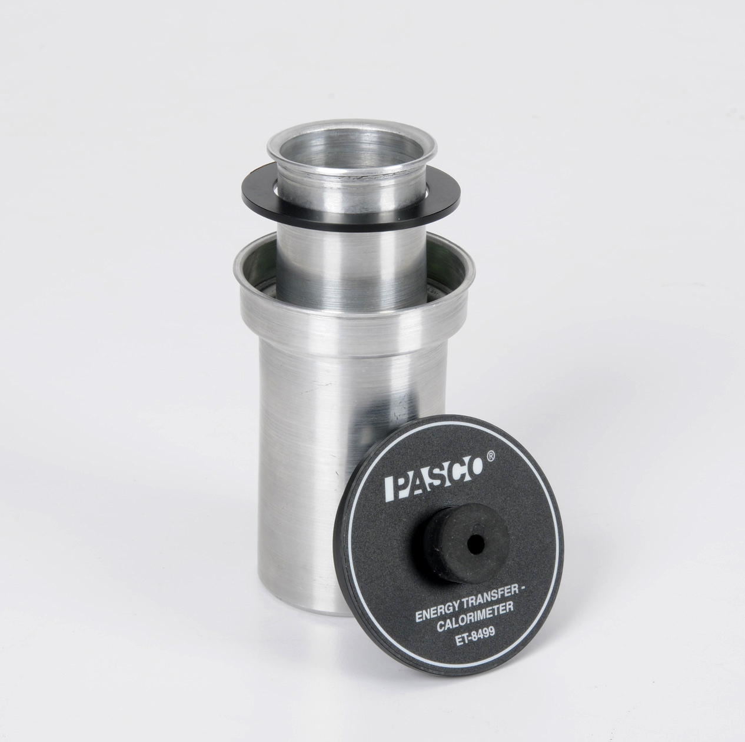 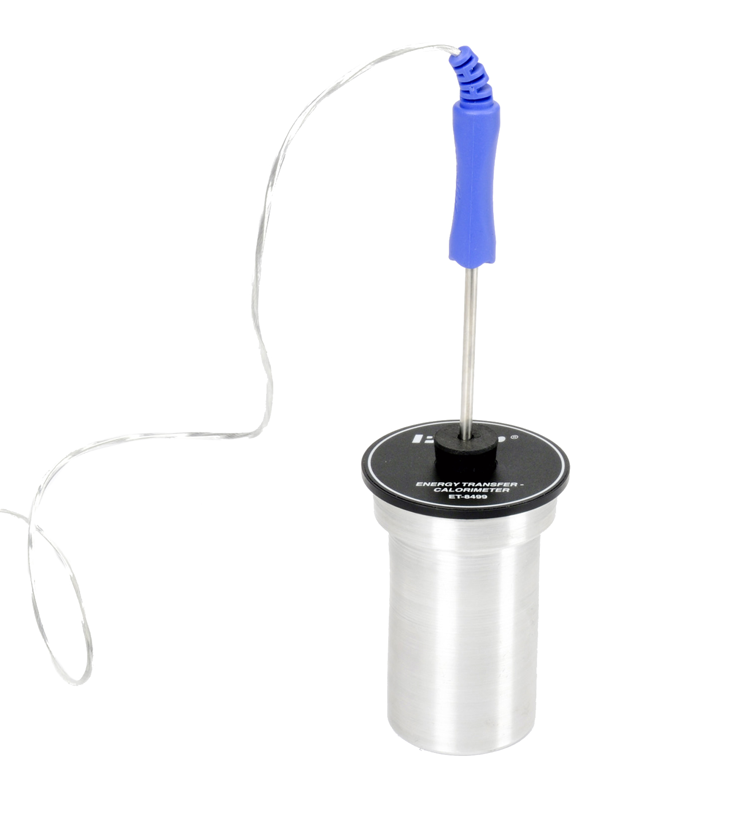

Figure 3: Calorimetry cup. Figure 4: Calorimeter with temperature probe.

* When the temperature of the warm water reaches 60 °C, switch off the hot plate and click stop in the Sampling Control Bar below (Fast Monitor Mode).

***Procedure***

* Place the temperature probe into the ice bath so that the tip of the probe is touching the gold-colored metal sample (Metal 1). Click the monitor button in the control panel to begin monitoring the temperature of Metal 1 in the digits display to the right.
* When the temperature measurement comes to equilibrium (stops changing), click stop in the control panel, and then record the temperature value shown in the digits display.
* Use the balance to measure the mass of the inner calorimeter cup, without its lid, to the nearest 0.01 g and record the value.
* Use the graduated cylinder to measure 30 ml of warm (~60 °C) water, and then pour the warm water into the inner calorimeter cup.
* Measure the mass of the inner calorimeter cup with water to the nearest 0.01 g and record the value. Using the Calorimeter Mass and Cal+Water Mass values, calculate the mass of the water.
* Put the inner cup into the outer cup of the calorimeter and put the lid on. Place the temperature probe into the warm water inside the calorimeter by inserting the probe through the one-hole stopper in the calorimeter lid. Gently swirl the water in the calorimeter for about 15 seconds to equilibrate the temperature inside the calorimeter.
* In Capstone, change the Sampling Mode to Continuous Mode and change the sample rate to 5 Hz. Create a graph of Temperature vs. Time.
* Click the record button in the control panel below to begin recording data, and continue to record data for about 20 seconds.

*The next step must be done quickly!*

* Using the paper clip and string, remove the gold-colored metal sample from the ice water bath. DO NOT TOUCH THE METAL WITH YOUR HANDS! Using paper towels, quickly dry off the metal and then lower it into the calorimeter cup and replace the calorimeter lid making sure that the very tip of the temperature probe is submerged in the calorimeter water and not in direct contact with the metal sample.
* Gently swirl the calorimeter cup until the temperature inside the cup comes to equilibrium. Then click stop.
* Remove the metal sample from the calorimeter cup and completely dry it using paper towels.
* Use the balance to measure the mass of the metal sample to the nearest 0.01 g and record the value.
* Use the Coordinates Tool in the graph to determine the initial temperature of the water just before you added the metal sample. Record this value.
* Use the Coordinates Tool in the graph to determine the final (equilibrium) temperature of the water once it has come to equilibrium. Record this value.
* Repeat for metal sample #2 (silver colored).

**Data:**

Metal 1 (gold-colored)

|  |  |
| --- | --- |
| Initial metal temperature  TiM [°C] |  |
| Equilibrium metal temperature  TeM [°C] |  |
| Calculated change in metal temperature  ΔTM [°C] |  |
| Initial water temperature  TiW [°C] |  |
| Equilibrium water temperature  TeW [°C] |  |
| Calculated change in water temperature  ΔTW [°C] |  |
| Metal sample mass  mM [g] |  |
| Calorimeter cup mass  mC [g] |  |
| Calorimeter cup + water mass  mC+W [g] |  |
| Calculated water mass  mW [g] |  |

Metal 2 (silver-colored)

|  |  |
| --- | --- |
| Initial metal temperature  TiM [°C] |  |
| Equilibrium metal temperature  TeM [°C] |  |
| Calculated change in metal temperature  ΔTM [°C] |  |
| Initial water temperature  TiW [°C] |  |
| Equilibrium water temperature  TeW [°C] |  |
| Calculated change in water temperature  ΔTW [°C] |  |
| Metal sample mass  mM [g] |  |
| Calorimeter cup mass  mC [g] |  |
| Calorimeter cup + water mass  mC+W [g] |  |
| Calculated water mass  mW [g] |  |

**Computations and Analysis:**

Using the data you recorded and Equation 3, calculate the specific heat of Metal 1. Show your work and record your results. Be certain to use correct units.

The gold-colored Metal 1 is made of brass which has a theoretical specific heat equal to cbrass = 0.380 J/g°C. Calculate the percent error in your experimental value using the equation below. Record your result.

$$\% error=\frac{\left|Theoretical-Experimental\right|}{Theoretical}×100\%$$

What are the three largest sources of potential error in your experimental value for metal 1? How did you limit these errors in measurements for metal 2?

Using the data you recorded and Equation 3, calculate the specific heat of Metal 2. Show your work and record your results. Be certain to use correct units.

Compare your calculated specific heat for metal 2 to the table below and determine which material the metal 2 sample is made of. Record additional observations to support your answer.

|  |  |  |  |
| --- | --- | --- | --- |
| Metal | Specific Heat (J/g°C) | Metal | Specific Heat (J/g°C) |
| Silver | 0.233 | Tungsten | 0.134 |
| Zinc | 0.387 | Aluminum | 0.900 |
| Stainless Steel | 0.500 | Lead | 0.128 |

Metal 2 sample is ___________________________________________________

Calculate the percent error in your experimental value using the equation below. Record your result.

$$\% error=\frac{\left|Theoretical-Experimental\right|}{Theoretical}×100\%$$

**Conclusions:**

1. Was your percent error larger for one of the metal samples? Why?
2. If both of your values for specific heat are too low when compared to known values, how can you explain that error?
3. What does the specific heat tell you about how easy it is to change the temperature of a material?

**Sources of errors:**

What assumptions were made that caused error? What is the uncertainty in your final calculation due to measurement limitations?